Business Question and Visualization Report
Date | 21-Aug-2026
Team ID | Individual
Project Name | Global AI Adoption in Education
Maximum Marks | 5 Marks
Business Questions and Visualizations
No. | Business Question | Visualization in Your Tableau Workbook | Purpose / Insight
1 | What is the overall level of AI adoption in education? | AI Adoption Levels – Bar Chart | To understand the overall AI adoption levels across the dataset.
2 | How does AI usage differ between students and teachers across countries? | AI Usage of Student and  Teacher – Country Wise –  Comparison Chart | To compare student and teacher AI usage for different countries.
3 | Which countries have the highest average daily AI usage? | Average Daily AI Usage by Country – Bar Chart | To identify countries where AI is used for the greatest amount of time per day.
4 | Which AI tools are the leading tools used in education? | Comparison of Leading AI  Tool – Comparison  Visualization | To compare the adoption/popularity of leading AI tools.
5 | How has AI usage changed in rural and urban areas over the years? | Growth of AI Usage in  Rural and Urban Area Yearwise – Line Chart | To identify the growth and difference between rural and urban AI usage over time.
6 | Which regions have the highest school AI adoption? | Region Wise Schools AI  Adoption – Region  Comparison Chart | To compare school-level AI adoption across regions.
7 | How have school, student, and teacher AI adoption changed over the years? | Year Wise School,  Students and Teacher AI Adoption –  Line/Comparison Chart | To identify AI adoption trends among schools, students, and teachers.
8 | Which countries have higher or lower AI adoption? | Global AI Adoption by  Country – Geographical  Map | To visualize geographical differences in AI adoption across countries.
9 | What are the key AI adoption KPIs? | Different KPI for the  Percentage of Use – KPI  Cards | To provide a quick overview of important AI adoption and usage indicators.
No. | Business Question | Visualization in Your Tableau Workbook | Purpose / Insight
10 | How does school AI adoption vary between regions? | Region Wise – Bar Chart | To identify regions with higher and lower school AI adoption.
11 | How does internet penetration relate to AI adoption in schools? | AI Adoption / Internet  Penetration Visualization | To explore whether internet access is associated with school AI adoption.
12 | How does rural AI usage compare with urban AI usage? | Rural vs Urban AI Usage | To identify the digital divide between rural and urban areas.
1. What is the overall level of AI adoption in education?

Visualization: AI Adoption Levels – Bar Chart
Attributes:
- Dimension: AI Adoption Level
- Measure: Percentage of AI Adoption
- Category: Education / AI Usage
Screenshot:
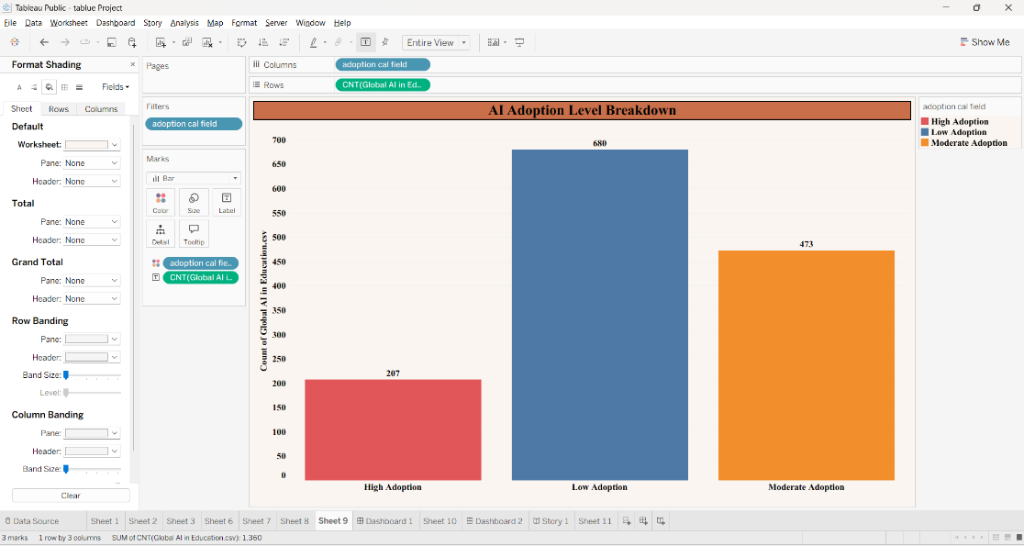

2. How does AI usage differ between students and teachers across countries?

Visualization: AI Usage of Student and Teacher – Country Wise
Attributes:
- Dimension: Country
- Measures: Student AI Usage, Teacher AI Usage
- Comparison: Student vs. Teacher
- Category: AI Usage
Screenshot:
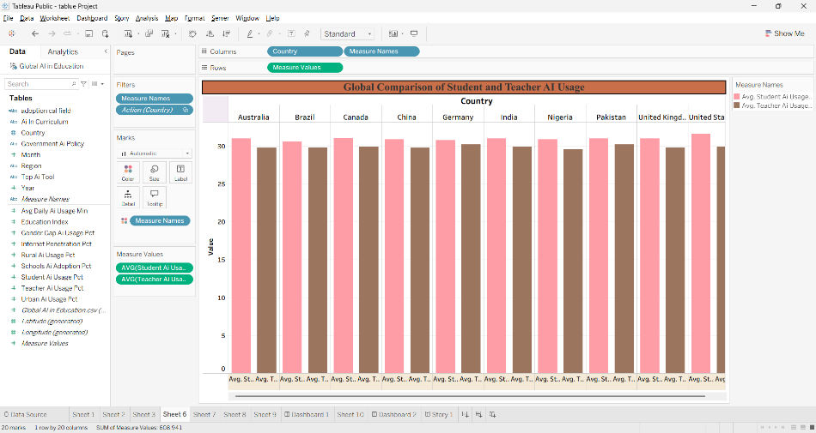

3. Which countries have the highest average daily AI usage?

Visualization: Average Daily AI Usage by Country
Attributes:
- Dimension: Country
- Measure: Average Daily AI Usage
- Unit: Daily Usage / Hours • Ranking: Country-wise AI Usage
Screenshot:

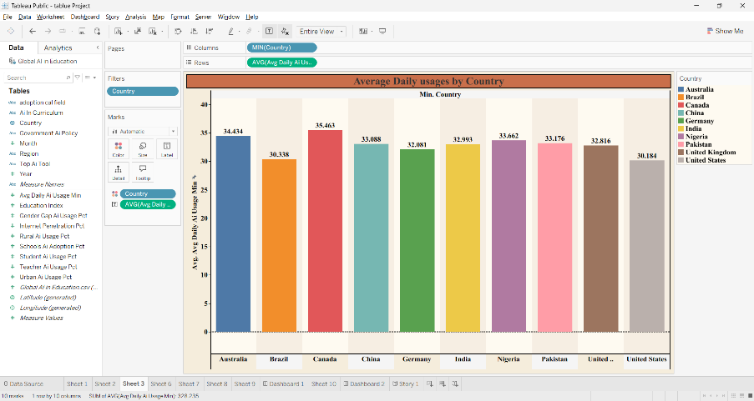
4. Which AI tools are the leading tools used in education?

Visualization: Comparison of Leading AI Tool
Attributes:
- Dimension: AI Tool
- Measure: AI Tool Usage / Adoption
- Category: Leading AI Tools
- Comparison: Tool-wise Usage

Screenshot:
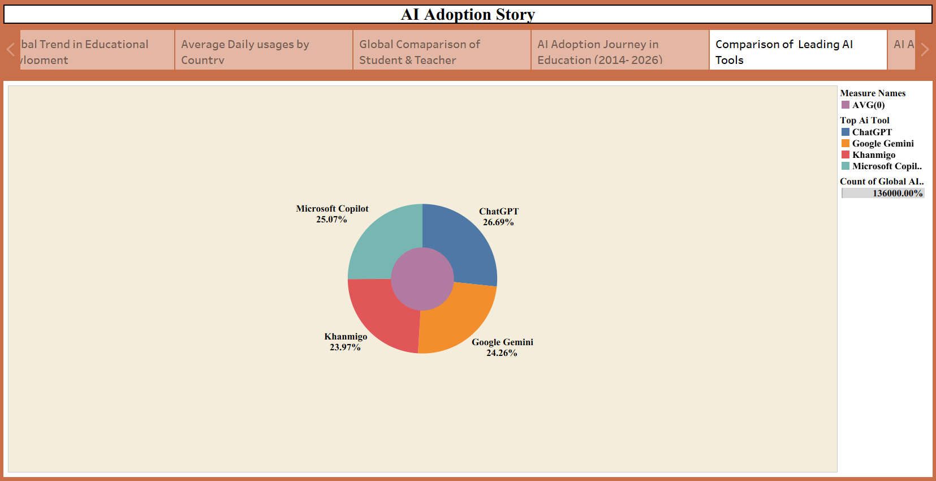

5. How has AI usage changed in rural and urban areas over the years?

Visualization: Growth of AI Usage in Rural and Urban Area
Attributes:
- Dimension: Year
- Category: Area Type — Rural / Urban
- Measure: AI Usage
- Comparison: Rural vs. Urban
- Trend: Year-wise Growth

Screenshot:

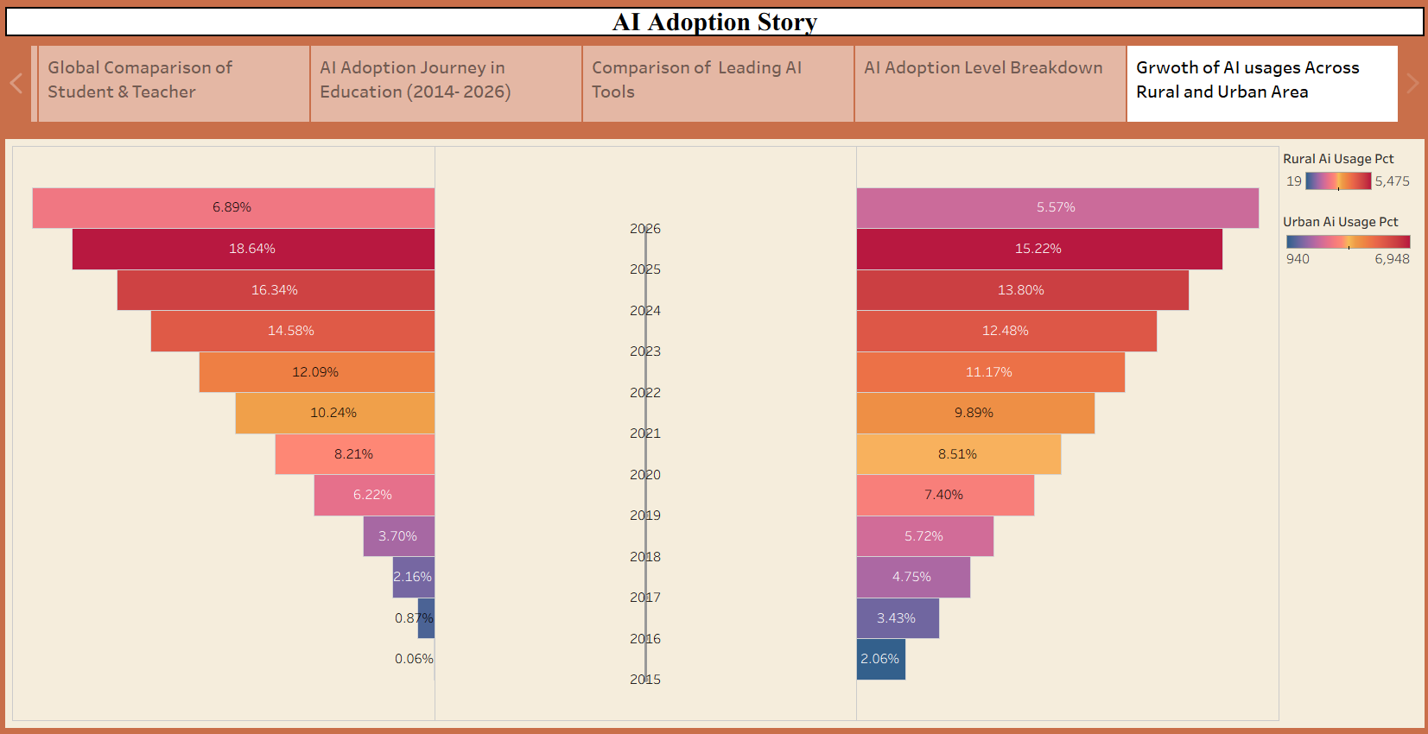

- Which regions have the highest school AI adoption?

Visualization: Region Wise Schools AI Adoption

Attributes:
- Dimension: Region
- Measure: School AI Adoption
- Category: Schools
- Comparison: Region-wise Adoption

Screenshot:
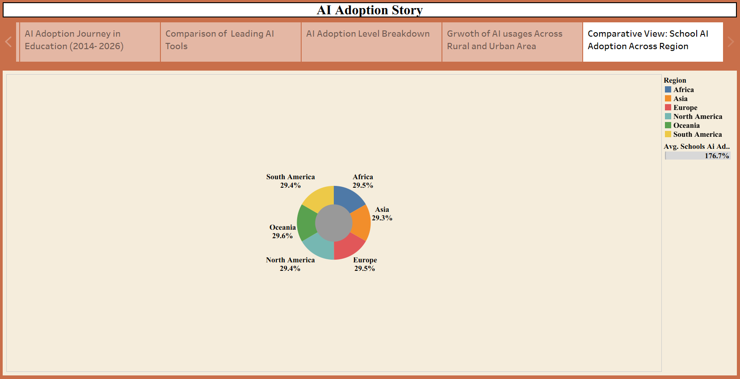

7. How have school, student, and teacher AI adoption changed over the years?

Visualization: Year Wise School, Students and Teacher AI Adoption
Attributes:
- Dimension: Year
- Measures: School AI Adoption, Student AI Adoption, Teacher AI Adoption
- Comparison: School vs. Student vs. Teacher
- Trend: Year-wise AI Adoption

Screenshot:

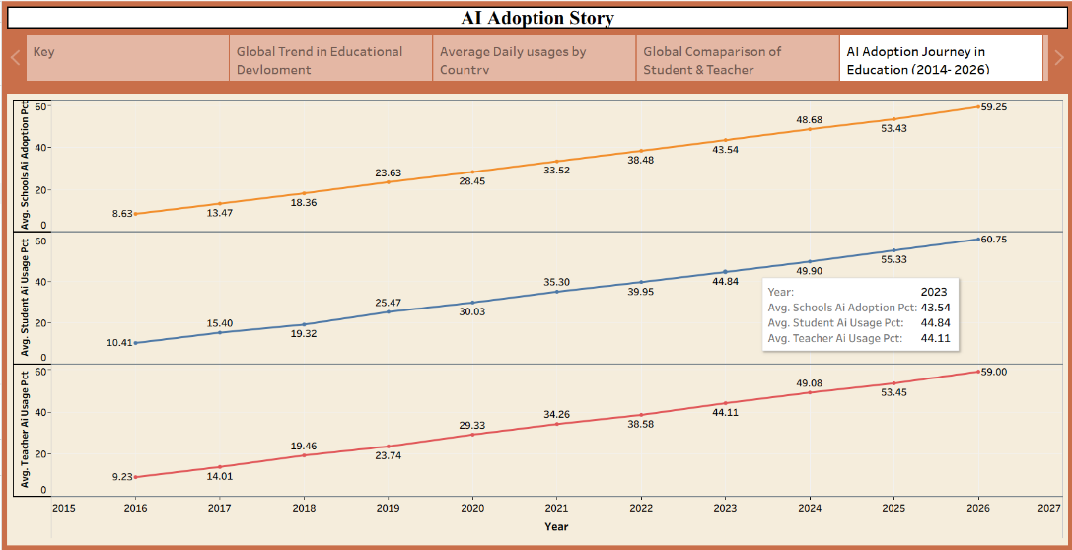

8. Which countries have higher or lower AI adoption?

Visualization: Global AI Adoption by Country – Map

Attributes:
- Geographical Dimension: Country
- Measure: AI Adoption
- Geographical Analysis: Country-wise
- Comparison: High vs. Low AI Adoption
- Map Attribute: Country Location

Screenshot:

